> summary(psid )

intnum persnum age educatn earnings hours kids married

Min. : 4 Min. : 1.00 Min. :30.0 Min. : 0.00 Min. : 0 Min. : 6 Min. : 0.000 divorced : 478

1st Qu.:1723 1st Qu.: 2.00 1st Qu.:34.0 1st Qu.:12.00 1st Qu.: 8000 1st Qu.:1213 1st Qu.: 1.000 married :2304

Median :5235 Median : 5.00 Median :38.0 Median :12.00 Median : 16000 Median :1856 Median : 2.000 NA/DF : 5

Mean :4296 Mean : 60.11 Mean :38.5 Mean :12.89 Mean : 18894 Mean :1633 Mean : 2.018 never married: 428

3rd Qu.:6413 3rd Qu.:170.00 3rd Qu.:43.0 3rd Qu.:14.00 3rd Qu.: 26000 3rd Qu.:2040 3rd Qu.: 3.000 no histories : 0

Max. :9306 Max. :199.00 Max. :50.0 Max. :17.00 Max. :240000 Max. :5025 Max. :10.000 separated : 203

widowed : 54

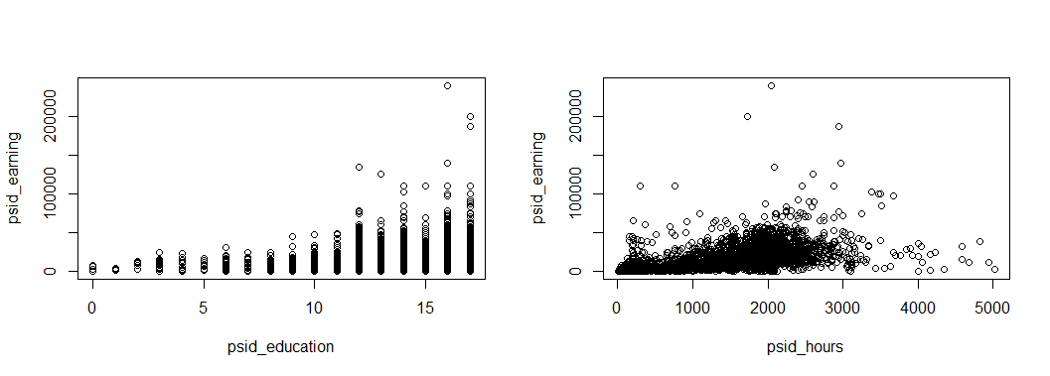

1. 2

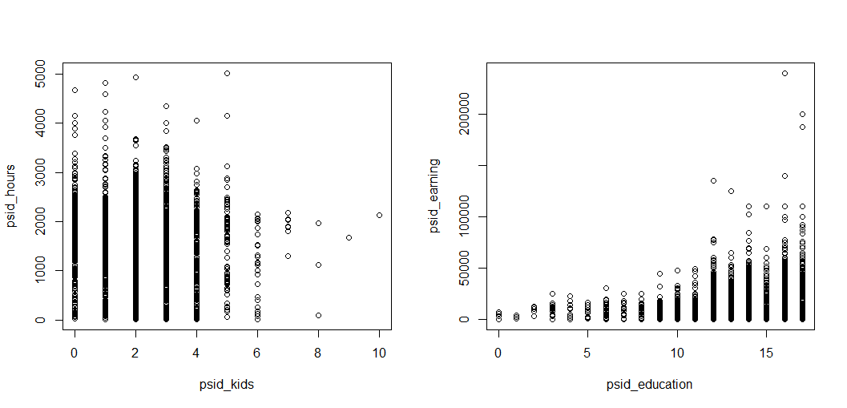

3 4

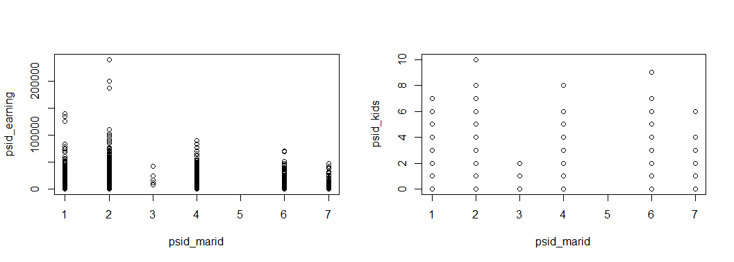

5 6

